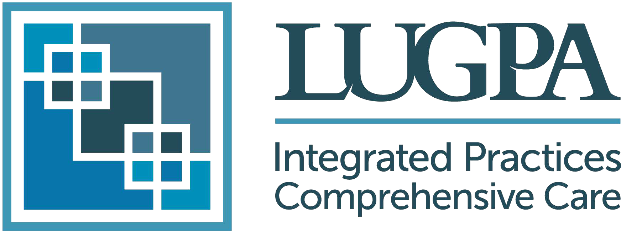

**2024 RESIDENT CLINICAL EXCELLENCEAWARD WORKSHEET**

**Please submit this completed worksheet as part of your entry.**

***The 2024 Resident Clinical Excellence Award is a merit award that recognizes qualities in a Resident that show their potential to be a highly effective leader at a private practice. The recipient of the award will be invited to the LUGPA Annual Meeting November 14-16, 2024, in Chicago, IL where the award will be announced and presented to the Resident.***

I**nnovation**: Highly skilled with the use of new technology or a device. Your nominee was integral in t*he development and execution of a novel process, technology, product, service, approach, or other idea that improved the status quo, and/or created value*.

**Problem Solving**: Implemented process and/or operational improvement. The nominee resolved an issue, challenge or problem with efficiency, process improvement, or technology.

**Clinical Involvement**: The nominee demonstrated an effective approach to diagnose, treat, prevent a disease, or improve a clinical process.

**Patient and Healthcare Team Interaction**: The nominee has superior patient interaction, bedside manner, and works-well with the entire healthcare team to improve treatment, care delivery or quality of service.

**Overall Impact**: The nominee has made a notable impact on your organization.

**Nominee Information**

Resident Name:  ­­­­

Email:

Cell Phone:

Residency Program:

Residency Completion Date:

**Reason for nomination:**

Provide background information about your nominee.

**Please comment on how the resident embodies the above selected criteria**

**Your Information**

Name:

Title:

Email:

Name of Program:

How do you know the resident?

**Nomination Permission**

* We will be reaching out to the Resident you nominated to inform them of their nomination. Once approved, we may also request more information from the Resident like a self-declaration.